Session -2 Lab
Assignment 1
Solution :-
class Student {
// Private member variables
private String studentName;
private String collegeName;
private int studentID;

// Main method
public static void main(String[] args) {
System.out.println("Successful");
}
}

Output :-
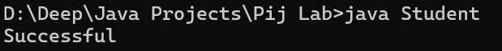

Assignment 2
Solution :-
class Employee {
// Protected member variables
protected int id;
protected int age;
protected String name;
protected boolean isPermanent;

public static void main(String[] args) {
Employee emp = new Employee();

// This line can cause compile-time error:
// emp.age = 35.5;
// Error: incompatible types: possible lossy conversion from double to int

// Corrected using casting:
emp.age = (int) 35.5; // This will assign 35 to age

System.out.println("Successfully started");
}
}

Output :-
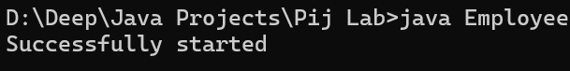

Assignment 3
Solution :-
class Person {
// Member variables initialized during declaration
String name = "John Doe";
int age = 30;
int salary = 50000;

public static void main(String[] args) {
System.out.println("Test Successful");
}
}
Output :-
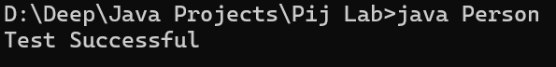
** After Modifying the classpath to see the error message

Assignment 4
Solution :-
class Rectangle {
// Member variables
double width;
double height;

// Enum declaration
enum Color {
RED, GREEN, BLUE
}

// Member variable of type Color
Color boxColor;

public static void main(String[] args) {
// Print the enum value
System.out.println(Color.BLUE);
}
}

Output :-
